COURSE CODE/TITLE: |  |  | SECTION: | CPES411
DATE PERFORMED: | JUNE 22 2026 |  | DATE SUBMITTED: | JUNE 22 2026
NAME: | Evangelista,Sean Andrei P. |  | INSTRUCTOR:

ACTIVITY NO. ___ | [ACTIVITY NAME]
1. PROCEDURE OUTPUT
1Try to create a simple program using C++ language that outputs your whole name. Using the new line
syntax, output your program and the course and section.
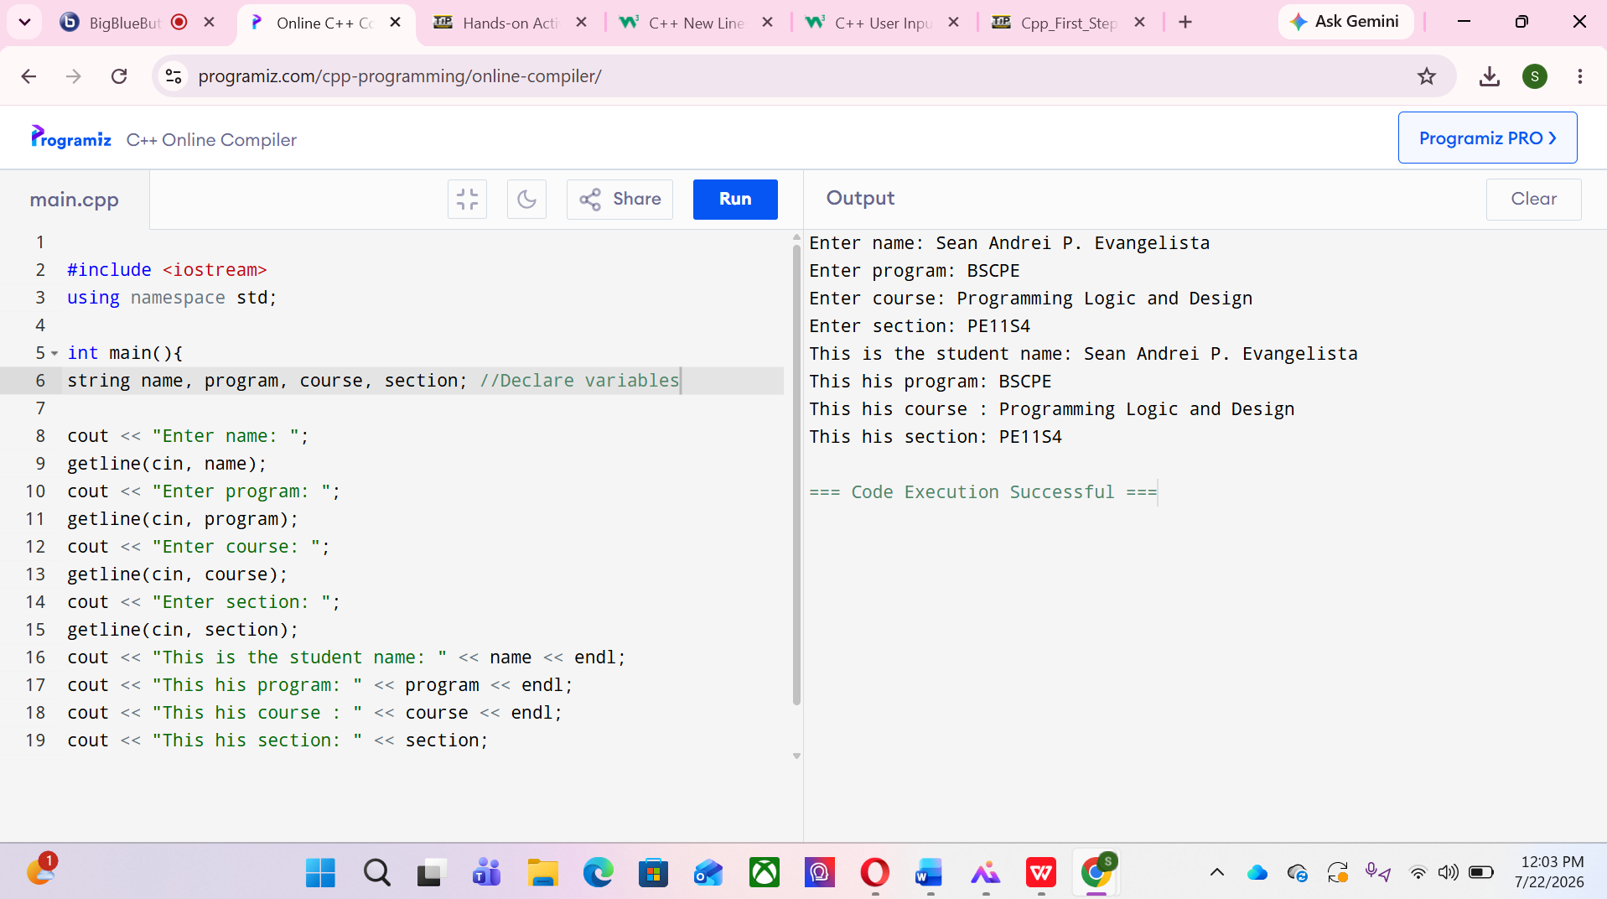

- Find all possible compilation errors and logic errors. Fix them. Your version of the program must print the same result as the expected output. Before you use your compiler, try to find the errors only by manual code analysis.
ANS: First there no use of namespace std;. and there also no << before the count. There also no parenthesis

- Design an algorithm that reads the base and height of a triangle and displays its area
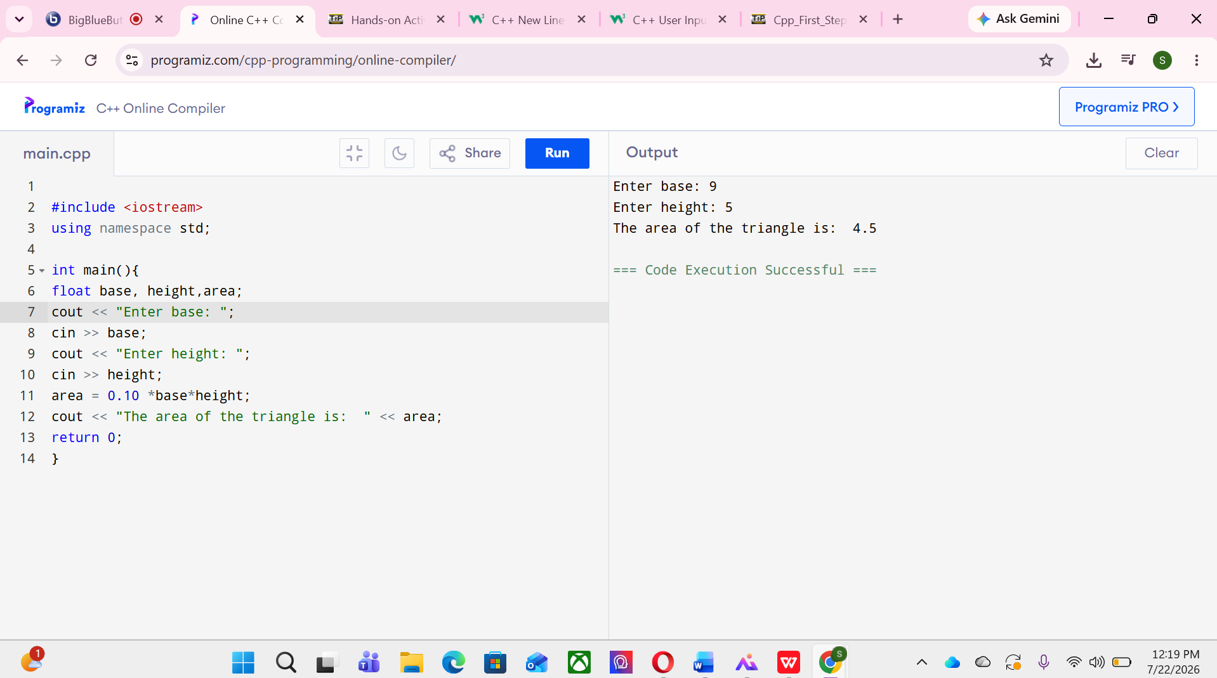
2. ANSWERS TO SUPPLEMENTAL ACTIVITY
Copy and paste the questions from the lab and include your answers after.

1.Design an algorithm that reads the midterm grade, final grade, and laboratory grade of a student and
displays the average grade.
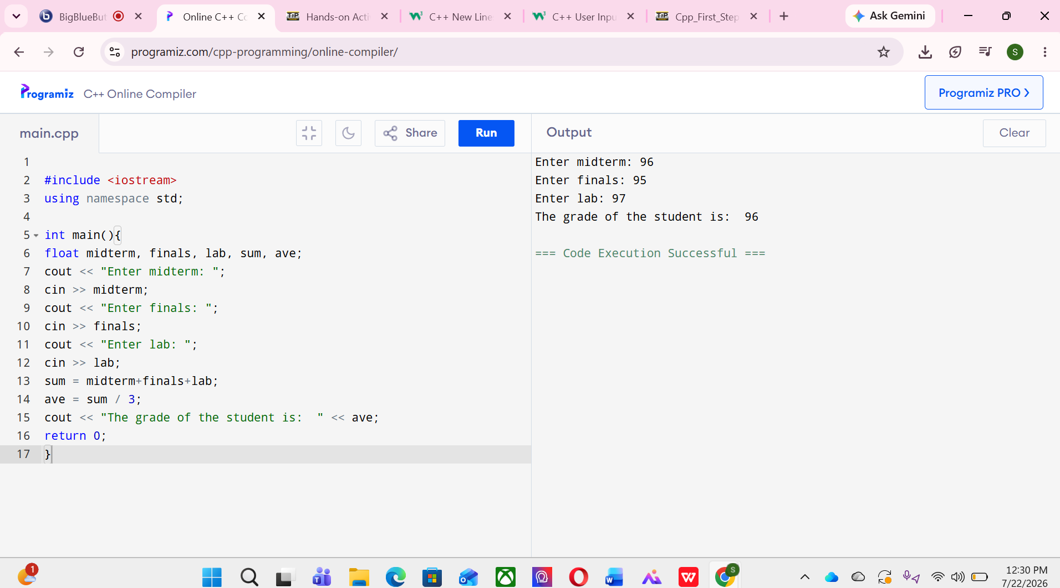

2,Design an algorithm that reads the name of a product, unit price, and quantity purchased, then displays the
product name, quantity, and total amount to pay.
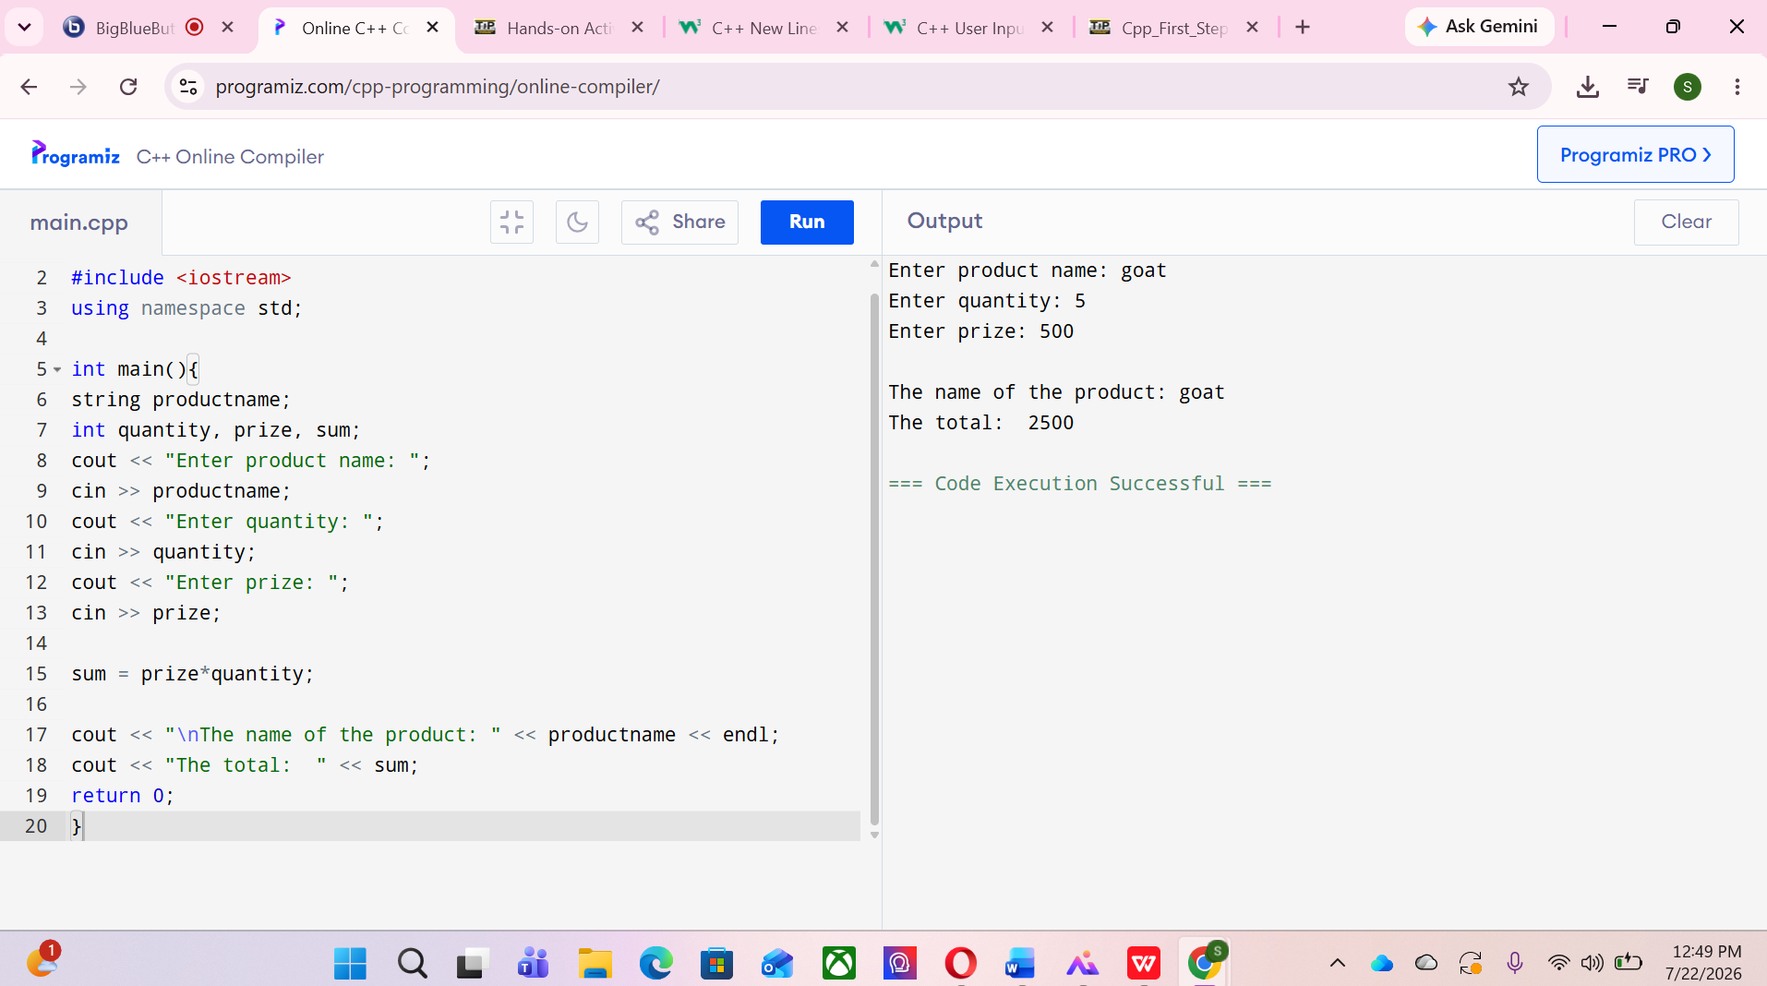
3. ARTIFICIAL INTELLIGENCE (AI) USE DISCLOSURE STATEMENT
I hereby declare that artificial intelligence (AI) tools were used, if applicable, in the preparation of this academic work. The following indicates the nature and extent of AI assistance:

Tools Used:
Examples: ChatGPT, Microsoft Copilot, Grammarly, QuillBot, etc.

Purpose of Use:
Examples: grammar correction, idea generation, formatting, summarization, code assistance, explanation of concepts, etc.

Extent of Use:
Explain how AI was used and confirm that it did not replace original thinking, analysis, authorship, or completion of the required work.

By submitting this activity, I affirm that my use of AI complies with T.I.P.’s AI usage policy and does not exceed the permitted limits for similarity, automated content generation, or academic assistance.

I understand that any false, incomplete, or misleading disclosure may be subject to investigation in accordance with due process and may result in sanctions for violation of existing T.I.P. policies.

Lab activities, templates, and related instructional materials shall not be reuploaded, reproduced, distributed, or shared with external organizations or third parties without the prior express written permission of the Technological Institute of the Philippines.

